

**MIT Art, Design and Technology University**

**MIT School of Computing, Pune**

**Department of Information Technology**

| **Lab Manual** |
| --- |

# **Practical - Web Programming**

# **Class - S.Y. (SEM-II), DA**

# **Batch - TY-IT-SMAD**

# **Name of the Student**

# **Mr. Ritesh J Prajapati**

**A.Y. 2024 – 2025 (SEM-II)**

| **Assignment No 1: Project Assignment based on Unit-I and Unit-II** | | | | |
| --- | --- | --- | --- | --- |
| **Project-I** | Project Title: ReactJS E-Commerce Website with Page RoutingProject Statement: Objective: Develop a fully functional E-commerce website using ReactJS that includes page routing functionality for smooth navigation between different sections like Home, Product Listing, Product Details, Cart, and Checkout. Project Features:  1. Navigation Bar with Routing:    * Create a Navigation Bar at the top of the website with links to:      + Home: Displays featured products and general information about the store.      + Products: Lists all available products for purchase.      + Cart: Displays the products added to the shopping cart.      + Checkout: Allows the user to review and complete the purchase.      + Profile: Displays user account information and order history.    * Implement React Router for routing between these pages. 2. Home Page:    * The Home page should showcase highlighted products or categories.    * Implement a product carousel or featured section.    * Include a search bar to allow users to search for products directly. 3. Product Listing Page:    * Create a Product Listing page that fetches products dynamically from an API or static JSON file.    * Each product in the list should show:      + Product image.      + Product name.      + Price.      + A button to add the product to the cart.    * Implement React Router links on product items to navigate to the Product Details page. 4. Product Details Page:    * When a user clicks on a product, navigate them to the Product Details page.    * The Product Details page should display:      + Full-size product image.      + Detailed product description.      + Price.      + Add to Cart button.    * Allow users to select product quantity before adding it to the cart. 5. Cart Page:    * Implement a Cart page that displays products added to the cart.    * Each cart item should include:      + Product name.      + Product quantity.      + Price per item and total cost for the item.      + A button to remove items from the cart.    * Display a total price for all items in the cart.    * Include buttons for Continue Shopping and Proceed to Checkout. 6. Checkout Page:    * Create a Checkout page where users can review their cart, enter shipping information, and confirm the order.    * Display an order summary with total cost, shipping details, and payment options.    * Provide a Place Order button to finalize the transaction. 7. User Profile Page:    * Create a Profile page where users can view their account information and order history.    * Include a form to update the profile details (name, email, shipping address). 8. State Management with Context API/Redux:    * Use React Context API or Redux to manage the global state of the cart, allowing users to add, remove, and update quantities of products across different pages.    * Ensure that the cart data is preserved during navigation between pages. 9. Responsive Design:    * Ensure the website is responsive and works well on both desktop and mobile devices using CSS Flexbox or CSS Grid.  Technical Requirements:ReactJS: For building the user interface.React Router: For implementing page routing functionality.State Management: Use React Context API or Redux to manage cart state and other global data.API Integration: Fetch products from a static JSON file or a mock API (e.g., JSONPlaceholder or a custom API).Responsive Styling: Use CSS/SCSS to ensure the website is mobile-friendly.Optional: Add localStorage or sessionStorage to persist cart data between page reloads.Expected Outcome: By completing this project, you will:   * Learn how to implement page routing in a ReactJS application using React Router. * Build a dynamic E-commerce website with features like product listings, cart management, and checkout functionality. * Gain experience with state management and ensuring the cart data persists across different pages. * Develop a responsive, user-friendly interface that functions well on both mobile and desktop screens. | | | |
| **Assignment No 2: Project Assignment based on Unit-III, IV and V** | | | | |
| **Project-II** | Project Title: React Native E-Commerce ApplicationProject Statement: Objective: Build a fully functional E-commerce mobile application using React Native that integrates navigation, core components, user interaction, dynamic list rendering, and state management. Project Features:  1. User Authentication:    * Implement a simple login screen where users can enter their credentials (username and password).    * After successful login, navigate to the Home Screen. 2. Navigation:    * Set up react-navigation to allow users to navigate between the following screens using StackNavigator:      + Home Screen: Displays a list of products.      + Product Details Screen: Shows details of the selected product.      + Cart Screen: Displays products added to the shopping cart.      + Profile Screen: Displays user profile details.      + Settings Screen: Allows the user to modify their account settings. 3. Core Components & UI:    * Use core React Native components such as View, Text, Image, StyleSheet, and Button to build a user-friendly interface.    * Apply Flexbox for layout, ensuring responsiveness across different screen sizes. 4. Product List and Cart:    * On the Home Screen, render the list of products using FlatList. Each item should display a product image, name, and price.    * Implement a button for each product to add it to the Cart. 5. Handling User Interactions:    * Implement touch events to handle interactions such as adding products to the cart, navigating to the product details, and updating the cart.    * Use onPress to trigger actions like adding a product to the cart or navigating between screens. 6. Cart Management:    * Use React Context API for global state management to handle the cart’s data (adding/removing products).    * Show the cart’s content and total price on the Cart Screen. 7. Product Details:    * When a user clicks on a product in the Home Screen, navigate to the Product Details Screen and display detailed information about the product, such as the description, image, and price. 8. Responsive Design:    * Ensure that the app is responsive, and elements adjust properly to different screen sizes using Flexbox. 9. Rendering Lists with SectionList:    * On the Home Screen, group products by categories (e.g., electronics, clothing) and use SectionList to render them in separate sections with headers.  Technical Requirements:React Native with Expo CLI for development and testing.React Navigation for screen transitions.State Management using React Context API or useState, useReducer.Dynamic data rendering using FlatList and SectionList.Styling using StyleSheet and Flexbox for layout.Expected Outcome: By completing this project, students will gain hands-on experience with:   * Setting up and using React Native and React Navigation. * Building a fully interactive mobile application with dynamic data rendering and state management. * Applying Flexbox for responsive layouts and managing user interactions. * Creating a simple e-commerce app with multi-screen navigation, product lists, and state-driven cart functionality. | | | |

# 

# 

## **Experiment No.1**

## 

## **Problem Statement:**

To develop a responsive and user-friendly photography blog website named **OneShot**, which provides visitors with access to galleries, tutorials, community content, and essential pages like About, Contact, Login, and Register. The site should offer seamless navigation and an engaging layout suitable for photography enthusiasts.

## **Objective:**

Build a responsive multi-page website using **HTML, CSS, and JavaScript**.

Include key pages: Home, Gallery, Tutorials, Community, About Us, Contact, Login, and Register.

Display photography content in a visually appealing way.

Ensure user interaction through forms and navigation links.

## **Theory:**

Website development is the backbone of modern digital communication and branding. In this assignment, a photography blogging website was created with a clean interface and intuitive navigation. The frontend of the website was developed using **HTML** (HyperText Markup Language), **CSS** (Cascading Style Sheets), and **JavaScript** for interactivity.

#### **1. Web Technologies Used:**

* **HTML** structures the webpage content—defining headers, paragraphs, images, navigation menus, and buttons.
* **CSS** styles the appearance, ensuring that the user interface is visually appealing and accessible. The website uses consistent theming (black and white with yellow highlights) to reflect a creative yet professional tone suitable for photography enthusiasts.
* **JavaScript** (where applicable) is used to manage interactive features like dropdown menus, image sliders, or login validation.

#### **2. Structure of the Website:**

The website is divided into seven main components/pages:

* **Home Page** – Introduces the platform with a welcome message and navigation menu.
* **Gallery Page** – Displays curated collections of photographs uploaded by the admin or contributors.
* **Tutorials Page** – Offers tips, techniques, and video guides for photography.
* **Community Page** – Enables users to engage, comment, or share feedback.
* **About Us Page** – Provides background on the purpose and creators of the blog.
* **Login & Registration Pages** – Allow user authentication and profile management.

#### **3. Web Design Principles:**

The design follows responsive web design principles, ensuring the layout adjusts to different screen sizes. Key concepts include:

* **Mobile-first approach**
* **Accessibility and usability**
* **Navigation hierarchy and user experience (UX)**
* **Visual balance through grid layout and white space**

## **Code:**

A. Home page:

Code:

import React from 'react';

import Header from './Header';

import { useNavigate } from 'react-router-dom';

import './Home.css';

const featuredPhotos = [

{

id: '1',

title: 'Mountain Sunset',

url: 'https://images.unsplash.com/photo-1506744038136-46273834b3fb?auto=format&fit=crop&w=800&q=80',

photographer: 'John Doe',

category: 'Landscape'

},

{

id: '2',

title: 'Urban Life',

url: 'https://images.unsplash.com/photo-1465101046530-73398c7f28ca?auto=format&fit=crop&w=800&q=80',

photographer: 'Jane Smith',

category: 'Street'

},

{

id: '3',

title: 'Wildlife Moment',

url: 'https://images.unsplash.com/photo-1519125323398-675f0ddb6308?auto=format&fit=crop&w=800&q=80',

photographer: 'Mike Johnson',

category: 'Wildlife'

}

];

const categories = [

{

name: 'Landscape',

description: 'Capture the beauty of nature',

icon: '🏔️'

},

{

name: 'Portrait',

description: 'Professional portrait photography',

icon: '👤'

},

{

name: 'Street',

description: 'Urban life and city moments',

icon: '🌆'

},

{

name: 'Wildlife',

description: 'Animals in their natural habitat',

icon: '🦁'

}

];

const Home: React.FC = () => {

const navigate = useNavigate();

return (

<>

<Header />

<div className="home-container">

{/* Hero Section */}

<section className="hero-section">

<div className="hero-content">

<h1>Welcome to OneShot</h1>

<p>Discover the art of photography through our curated collection of stunning images</p>

<button onClick={() => navigate('/gallery')} className="cta-button">

Explore Gallery

</button>

</div>

</section>

{/* Featured Photos Section */}

<section className="featured-section">

<h2>Featured Photos</h2>

<div className="featured-grid">

{featuredPhotos.map(photo => (

<div key={photo.id} className="featured-card">

<img src={photo.url} alt={photo.title} />

<div className="featured-info">

<h3>{photo.title}</h3>

<p>By {photo.photographer}</p>

<span className="category-tag">{photo.category}</span>

</div>

</div>

))}

</div>

</section>

{/* Categories Section */}

<section className="categories-section">

<h2>Photo Categories</h2>

<div className="categories-grid">

{categories.map(category => (

<div key={category.name} className="category-card">

<span className="category-icon">{category.icon}</span>

<h3>{category.name}</h3>

<p>{category.description}</p>

</div>

))}

</div>

</section>

{/* Features Section */}

<section className="features-section">

<h2>Why Choose OneShot?</h2>

<div className="features-grid">

<div className="feature-card">

<h3>High Quality Prints</h3>

<p>Professional grade prints with vibrant colors and sharp details</p>

</div>

<div className="feature-card">

<h3>Fast Shipping</h3>

<p>Quick delivery with careful packaging to ensure your prints arrive safely</p>

</div>

<div className="feature-card">

<h3>Expert Photographers</h3>

<p>Work from talented photographers around the world</p>

</div>

<div className="feature-card">

<h3>Custom Sizes</h3>

<p>Choose from various sizes to fit your space perfectly</p>

</div>

</div>

</section>

{/* Newsletter Section */}

<section className="newsletter-section">

<div className="newsletter-content">

<h2>Stay Updated</h2>

<p>Subscribe to our newsletter for new photos, tips, and exclusive offers</p>

<form className="newsletter-form">

<input type="email" placeholder="Enter your email" required />

<button type="submit">Subscribe</button>

</form>

</div>

</section>

</div>

</>

);

};

export default Home;

**CSS code:**

.home-container {

max-width: 1200px;

margin: 0 auto;

padding: 0 1rem;

}

/* Hero Section */

.hero-section {

background: linear-gradient(rgba(0, 0, 0, 0.5), rgba(0, 0, 0, 0.5)),

url('https://images.unsplash.com/photo-1506744038136-46273834b3fb?auto=format&fit=crop&w=1920&q=80');

background-size: cover;

background-position: center;

height: 500px;

display: flex;

align-items: center;

justify-content: center;

text-align: center;

color: white;

margin-bottom: 4rem;

border-radius: 8px;

}

.hero-content {

max-width: 800px;

padding: 2rem;

}

.hero-content h1 {

font-size: 3rem;

margin-bottom: 1rem;

}

.hero-content p {

font-size: 1.2rem;

margin-bottom: 2rem;

}

.cta-button {

padding: 1rem 2rem;

font-size: 1.1rem;

background-color: #007bff;

color: white;

border: none;

border-radius: 4px;

cursor: pointer;

transition: background-color 0.2s;

}

.cta-button:hover {

background-color: #0056b3;

}

/* Featured Photos Section */

.featured-section {

margin-bottom: 4rem;

}

.featured-section h2 {

text-align: center;

margin-bottom: 2rem;

color: #333;

}

.featured-grid {

display: grid;

grid-template-columns: repeat(auto-fit, minmax(300px, 1fr));

gap: 2rem;

}

.featured-card {

background: white;

border-radius: 8px;

overflow: hidden;

box-shadow: 0 2px 4px rgba(0, 0, 0, 0.1);

transition: transform 0.2s;

}

.featured-card:hover {

transform: translateY(-5px);

}

.featured-card img {

width: 100%;

height: 250px;

object-fit: cover;

}

.featured-info {

padding: 1.5rem;

}

.featured-info h3 {

margin: 0 0 0.5rem 0;

color: #333;

}

.featured-info p {

color: #666;

margin: 0 0 1rem 0;

}

.category-tag {

display: inline-block;

padding: 0.25rem 0.75rem;

background-color: #e9ecef;

color: #495057;

border-radius: 20px;

font-size: 0.9rem;

}

/* Categories Section */

.categories-section {

margin-bottom: 4rem;

}

.categories-section h2 {

text-align: center;

margin-bottom: 2rem;

color: #333;

}

.categories-grid {

display: grid;

grid-template-columns: repeat(auto-fit, minmax(250px, 1fr));

gap: 2rem;

}

.category-card {

background: white;

padding: 2rem;

border-radius: 8px;

text-align: center;

box-shadow: 0 2px 4px rgba(0, 0, 0, 0.1);

transition: transform 0.2s;

}

.category-card:hover {

transform: translateY(-5px);

}

.category-icon {

font-size: 3rem;

margin-bottom: 1rem;

display: block;

}

.category-card h3 {

margin: 0 0 0.5rem 0;

color: #333;

}

.category-card p {

color: #666;

margin: 0;

}

/* Features Section */

.features-section {

margin-bottom: 4rem;

}

.features-section h2 {

text-align: center;

margin-bottom: 2rem;

color: #333;

}

.features-grid {

display: grid;

grid-template-columns: repeat(auto-fit, minmax(250px, 1fr));

gap: 2rem;

}

.feature-card {

background: white;

padding: 2rem;

border-radius: 8px;

text-align: center;

box-shadow: 0 2px 4px rgba(0, 0, 0, 0.1);

}

.feature-card h3 {

margin: 0 0 1rem 0;

color: #333;

}

.feature-card p {

color: #666;

margin: 0;

}

/* Newsletter Section */

.newsletter-section {

background: #f8f9fa;

padding: 4rem 2rem;

border-radius: 8px;

margin-bottom: 4rem;

}

.newsletter-content {

max-width: 600px;

margin: 0 auto;

text-align: center;

}

.newsletter-content h2 {

margin: 0 0 1rem 0;

color: #333;

}

.newsletter-content p {

color: #666;

margin: 0 0 2rem 0;

}

.newsletter-form {

display: flex;

gap: 1rem;

}

.newsletter-form input {

flex: 1;

padding: 0.75rem;

border: 1px solid #ddd;

border-radius: 4px;

font-size: 1rem;

}

.newsletter-form button {

padding: 0.75rem 1.5rem;

background-color: #007bff;

color: white;

border: none;

border-radius: 4px;

cursor: pointer;

transition: background-color 0.2s;

}

.newsletter-form button:hover {

background-color: #0056b3;

}

/* Responsive Design */

@media (max-width: 768px) {

.hero-content h1 {

font-size: 2rem;

}

.hero-content p {

font-size: 1rem;

}

.newsletter-form {

flex-direction: column;

}

.newsletter-form button {

width: 100%;

}

}

## **Output:**

A. Home page output:

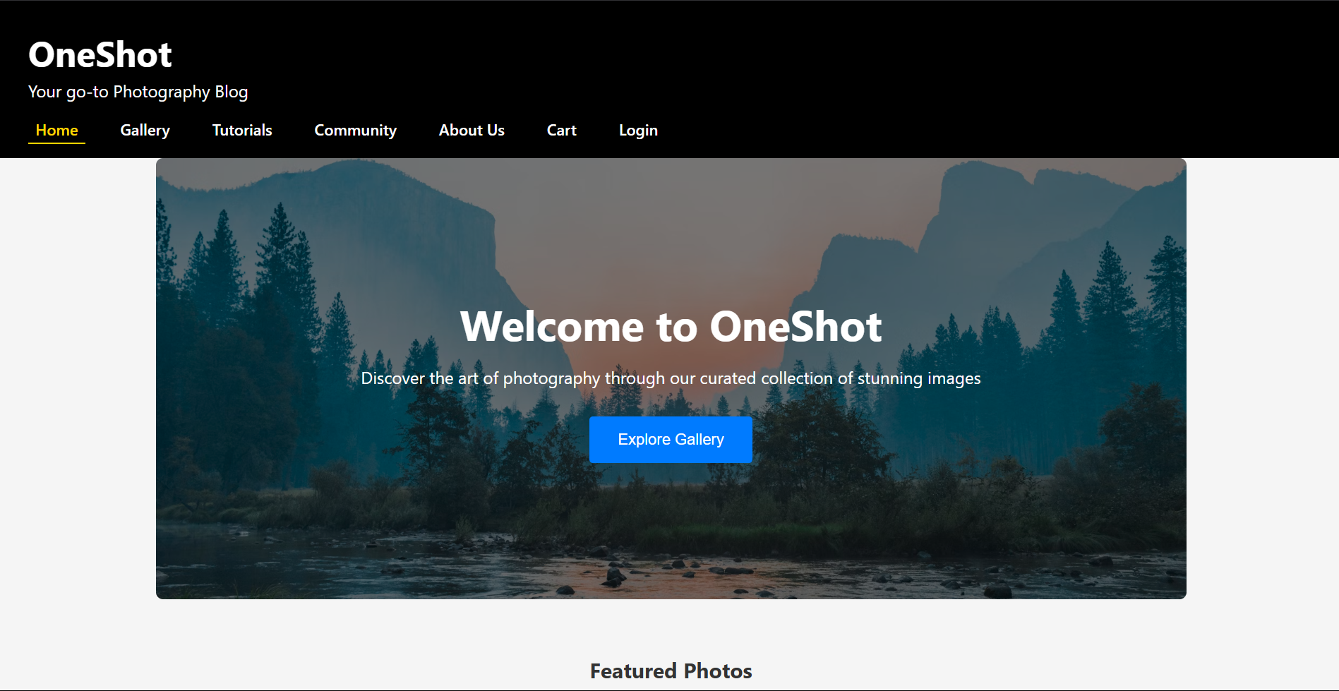

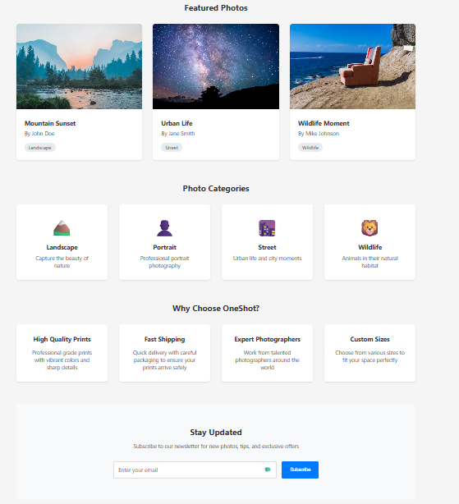

## **Code:**

B. Gallery page:

Code:

import React, { useState, useEffect } from 'react';

import Header from './Header';

import { Photo } from '../types';

import './Gallery.css';

const initialPhotos: Photo[] = [

{

id: '1',

url: 'https://images.unsplash.com/photo-1506744038136-46273834b3fb?auto=format&fit=crop&w=400&q=80',

title: 'Beautiful Landscape',

description: 'A stunning view of mountains',

uploadedBy: 'user1',

uploadDate: new Date(),

},

{

id: '2',

url: 'https://images.unsplash.com/photo-1465101046530-73398c7f28ca?auto=format&fit=crop&w=400&q=80',

title: 'City Lights',

description: 'Night view of the city',

uploadedBy: 'user2',

uploadDate: new Date(),

},

{

id: '3',

url: 'https://images.unsplash.com/photo-1519125323398-675f0ddb6308?auto=format&fit=crop&w=400&q=80',

title: 'Forest Path',

description: 'A peaceful walk in the woods',

uploadedBy: 'user3',

uploadDate: new Date(),

},

{

id: '4',

url: 'https://images.unsplash.com/photo-1500534314209-a25ddb2bd429?auto=format&fit=crop&w=400&q=80',

title: 'Desert Dunes',

description: 'Golden sands under a blue sky',

uploadedBy: 'user4',

uploadDate: new Date(),

},

];

const Gallery: React.FC = () => {

const [photos, setPhotos] = useState<Photo[]>([]);

const [loading, setLoading] = useState(true);

const [showModal, setShowModal] = useState(false);

const [newPhoto, setNewPhoto] = useState<{ title: string; description: string; file: File | null; preview: string | null }>({ title: '', description: '', file: null, preview: null });

useEffect(() => {

setPhotos(initialPhotos);

setLoading(false);

}, []);

const handleOpenModal = () => setShowModal(true);

const handleCloseModal = () => {

setShowModal(false);

setNewPhoto({ title: '', description: '', file: null, preview: null });

};

const handleFileChange = (e: React.ChangeEvent<HTMLInputElement>) => {

const file = e.target.files?.[0] || null;

if (file) {

const reader = new FileReader();

reader.onloadend = () => {

setNewPhoto((prev) => ({ ...prev, file, preview: reader.result as string }));

};

reader.readAsDataURL(file);

}

};

const handleAddPhoto = (e: React.FormEvent) => {

e.preventDefault();

if (!newPhoto.title || !newPhoto.file || !newPhoto.preview) return;

const newId = (photos.length + 1).toString();

const photo: Photo = {

id: newId,

url: newPhoto.preview,

title: newPhoto.title,

description: newPhoto.description,

uploadedBy: 'You',

uploadDate: new Date(),

};

setPhotos([photo, ...photos]);

handleCloseModal();

};

return (

<>

<Header />

<div className="welcome-section">

<h1>Welcome to OneShot</h1>

<p>Explore the world through the lens. Discover stunning photography, learn new techniques, and be part of our vibrant community.</p>

<p>Start your photographic journey today!</p>

</div>

<div className="gallery-container">

<div style={{ display: 'flex', justifyContent: 'space-between', alignItems: 'center', marginBottom: 24 }}>

<h2>Photo Gallery</h2>

<button className="upload-button" style={{ width: 'auto', padding: '0.5rem 1.5rem' }} onClick={handleOpenModal}>Add Photo</button>

</div>

{loading ? (

<div className="loading">Loading...</div>

) : (

<div className="gallery-grid">

{photos.map((photo) => (

<div key={photo.id} className="photo-card">

<img src={photo.url} alt={photo.title} />

<div className="photo-info">

<h3>{photo.title}</h3>

<p>{photo.description}</p>

<div className="photo-meta">

<span>By: {photo.uploadedBy}</span>

<span>{photo.uploadDate.toLocaleDateString()}</span>

</div>

</div>

</div>

))}

</div>

)}

</div>

{showModal && (

<div className="modal-overlay">

<div className="modal-content">

<h2>Add a New Photo</h2>

<form onSubmit={handleAddPhoto} className="upload-form">

<div className="form-group">

<label htmlFor="title">Title</label>

<input

type="text"

id="title"

value={newPhoto.title}

onChange={(e) => setNewPhoto((prev) => ({ ...prev, title: e.target.value }))}

required

/>

</div>

<div className="form-group">

<label htmlFor="description">Description</label>

<textarea

id="description"

value={newPhoto.description}

onChange={(e) => setNewPhoto((prev) => ({ ...prev, description: e.target.value }))}

rows={3}

/>

</div>

<div className="form-group">

<label htmlFor="photo">Photo</label>

<input

type="file"

id="photo"

accept="image/*"

onChange={handleFileChange}

required

/>

</div>

{newPhoto.preview && (

<div className="preview-container">

<img src={newPhoto.preview} alt="Preview" className="preview-image" />

</div>

)}

<div style={{ display: 'flex', justifyContent: 'flex-end', gap: 12, marginTop: 16 }}>

<button type="button" className="upload-button" style={{ background: '#888' }} onClick={handleCloseModal}>Cancel</button>

<button type="submit" className="upload-button" disabled={!newPhoto.title || !newPhoto.file}>Add Photo</button>

</div>

</form>

</div>

</div>

)}

</>

);

};

export default Gallery;

## **Output:**

B. Gallery page output:

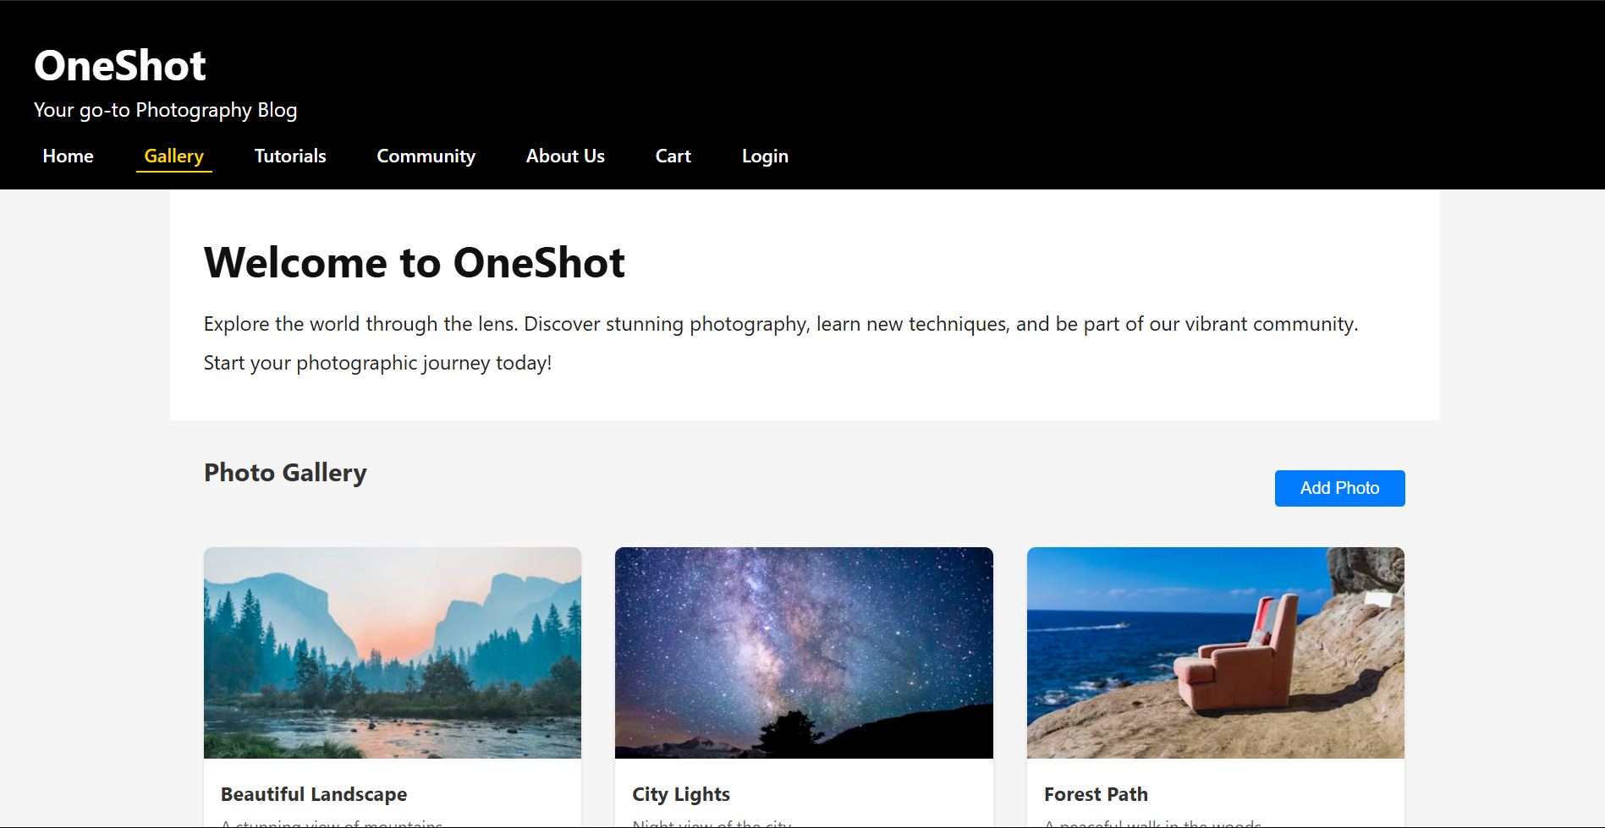

## **Code:**

C. Tutorialspage:

Code:

import React from 'react';

import Header from './Header';

const Tutorials: React.FC = () => (

<>

<Header />

<div className="welcome-section">

<h1>Tutorials</h1>

<p>Learn new photography techniques, tips, and tricks from our curated tutorials. Whether you're a beginner or a pro, there's something here for everyone!</p>

<ul>

<li><a href="https://www.youtube.com/watch?v=7b6lGk5G4xM" target="_blank" rel="noopener noreferrer">Getting Started with DSLR Cameras (YouTube)</a></li>

<li><a href="https://www.youtube.com/watch?v=7ZVyNjKSr0M" target="_blank" rel="noopener noreferrer">Understanding Exposure and Lighting (YouTube)</a></li>

<li><a href="https://www.youtube.com/watch?v=7wqgU2FQK0w" target="_blank" rel="noopener noreferrer">Editing Basics: Make Your Photos Pop (YouTube)</a></li>

<li><a href="https://www.youtube.com/watch?v=1J0TQ3Qd5iA" target="_blank" rel="noopener noreferrer">Creative Composition Ideas (YouTube)</a></li>

</ul>

</div>

</>

);

export default Tutorials;

## **Output:**

C. Tutorials page output:

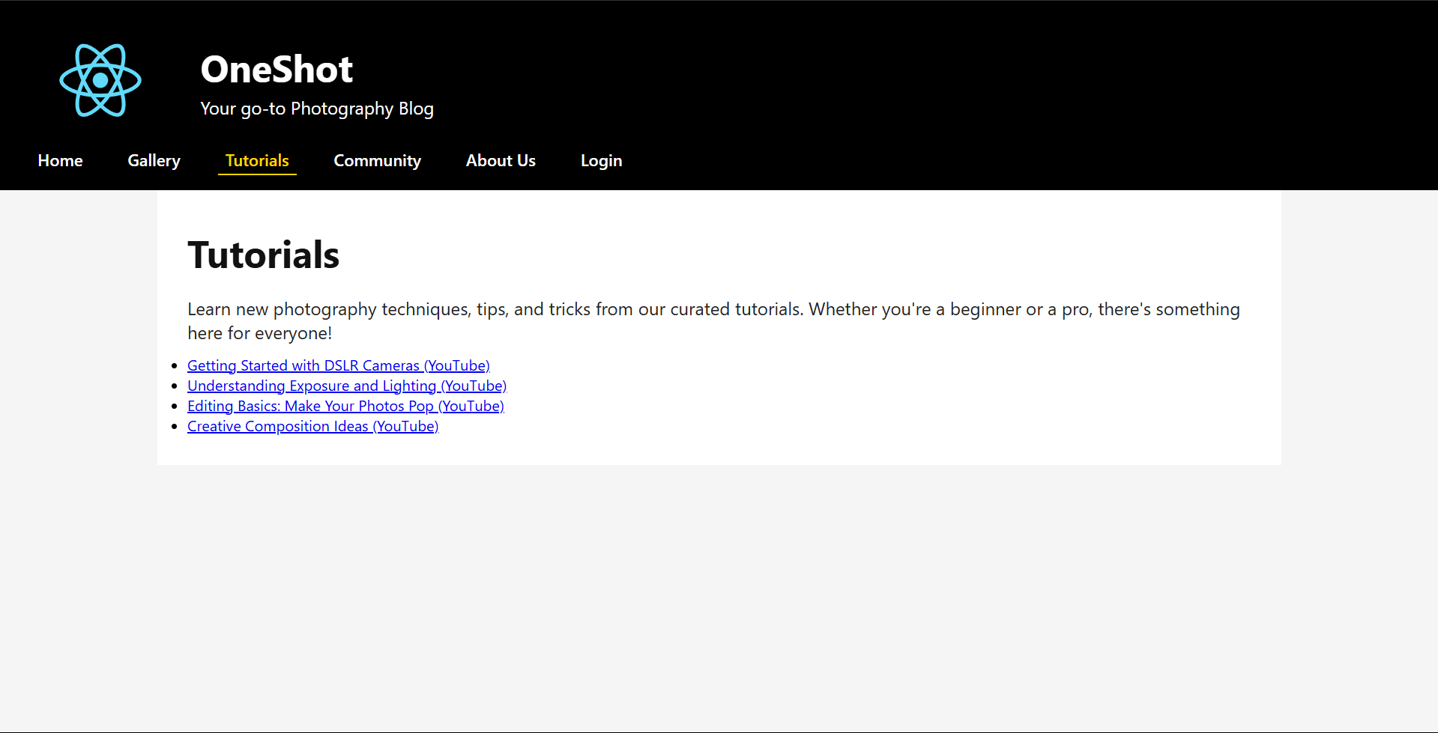

## **Code:**

D. about us page:

code:

import React from 'react';

import Header from './Header';

const About: React.FC = () => (

<>

<Header />

<div className="welcome-section">

<h1>About Us</h1>

<p>OneShot is your go-to photography blog and community. Our mission is to inspire, educate, and connect photographers of all levels.</p>

<p>We believe in the power of visual storytelling and strive to provide a platform where creativity can flourish. Thank you for being a part of our journey!</p>

<ul>

<li>Founded: 2024</li>

<li>Team: Passionate photographers & educators</li>

<li>Contact: info@oneshot.com</li>

</ul>

</div>

</>

);

export default About;

## **Output:**

D. about us page output:

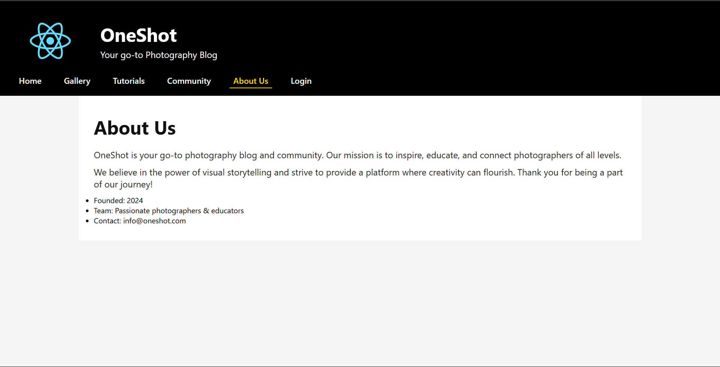

## **Code:**

E. Community page:

code:

import React from 'react';

import Header from './Header';

const photographers = [

{

name: 'Alice Johnson',

bio: 'Landscape photographer with a passion for mountains and sunsets.',

img: 'https://randomuser.me/api/portraits/women/44.jpg',

},

{

name: 'Brian Lee',

bio: 'Street photographer capturing candid moments in urban life.',

img: 'https://randomuser.me/api/portraits/men/32.jpg',

},

{

name: 'Carla Gomez',

bio: 'Wildlife photographer and conservationist.',

img: 'https://randomuser.me/api/portraits/women/68.jpg',

},

];

const Community: React.FC = () => (

<>

<Header />

<div className="welcome-section">

<h1>Community</h1>

<p>Join our vibrant community of photographers! Share your work, get feedback, and connect with fellow enthusiasts.</p>

<div style={{ display: 'flex', gap: '2rem', flexWrap: 'wrap', marginTop: '2rem' }}>

{photographers.map((p) => (

<div key={p.name} style={{ background: '#fafafa', borderRadius: 8, padding: 20, minWidth: 220, textAlign: 'center', boxShadow: '0 2px 8px #eee' }}>

<img src={p.img} alt={p.name} style={{ width: 80, height: 80, borderRadius: '50%', objectFit: 'cover', marginBottom: 12 }} />

<h3 style={{ margin: '0 0 0.5rem 0' }}>{p.name}</h3>

<p style={{ color: '#444', fontSize: '1rem' }}>{p.bio}</p>

</div>

))}

</div>

</div>

</>

);

export default Community;

## **Output:**

E. Community page output:

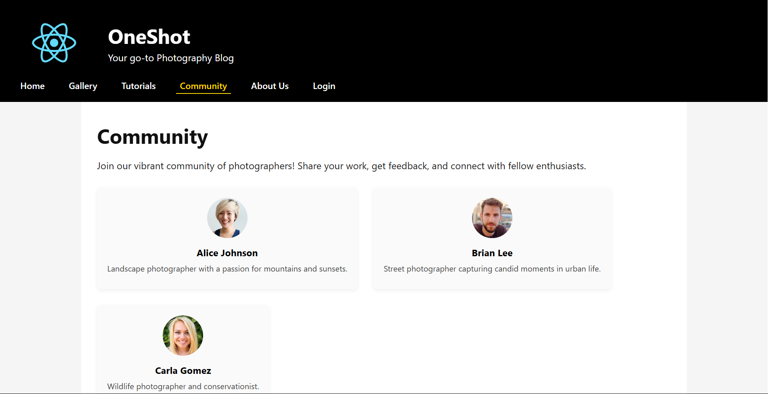

## **Code:**

F. Cart page:

Code:

import React from 'react';

import Header from './Header';

import { useNavigate } from 'react-router-dom';

import './Cart.css';

interface CartItem {

id: string;

title: string;

url: string;

price: number;

quantity: number;

size: string;

}

const Cart: React.FC = () => {

const navigate = useNavigate();

// Mock cart data - in a real app, this would come from a cart context or state management

const [cartItems, setCartItems] = React.useState<CartItem[]>([

{

id: '1',

title: 'Beautiful Landscape',

url: 'https://images.unsplash.com/photo-1506744038136-46273834b3fb?auto=format&fit=crop&w=400&q=80',

price: 29.99,

quantity: 1,

size: '8x10'

},

{

id: '2',

title: 'City Lights',

url: 'https://images.unsplash.com/photo-1465101046530-73398c7f28ca?auto=format&fit=crop&w=400&q=80',

price: 39.99,

quantity: 2,

size: '11x14'

}

]);

const updateQuantity = (id: string, newQuantity: number) => {

if (newQuantity < 1) return;

setCartItems(items =>

items.map(item =>

item.id === id ? { ...item, quantity: newQuantity } : item

)

);

};

const removeItem = (id: string) => {

setCartItems(items => items.filter(item => item.id !== id));

};

const calculateSubtotal = () => {

return cartItems.reduce((total, item) => total + (item.price * item.quantity), 0);

};

const calculateTax = () => {

return calculateSubtotal() * 0.08; // 8% tax

};

const calculateTotal = () => {

return calculateSubtotal() + calculateTax();

};

return (

<>

<Header />

<div className="cart-container">

<h1>Shopping Cart</h1>

{cartItems.length === 0 ? (

<div className="empty-cart">

<p>Your cart is empty</p>

<button onClick={() => navigate('/gallery')} className="continue-shopping">

Continue Shopping

</button>

</div>

) : (

<>

<div className="cart-items">

{cartItems.map(item => (

<div key={item.id} className="cart-item">

<div className="item-image">

<img src={item.url} alt={item.title} />

</div>

<div className="item-details">

<h3>{item.title}</h3>

<p>Size: {item.size}</p>

<p>Price: ${item.price.toFixed(2)}</p>

<div className="quantity-controls">

<button onClick={() => updateQuantity(item.id, item.quantity - 1)}>-</button>

<span>{item.quantity}</span>

<button onClick={() => updateQuantity(item.id, item.quantity + 1)}>+</button>

</div>

</div>

<div className="item-total">

<p>${(item.price * item.quantity).toFixed(2)}</p>

<button onClick={() => removeItem(item.id)} className="remove-button">

Remove

</button>

</div>

</div>

))}

</div>

<div className="cart-summary">

<div className="summary-row">

<span>Subtotal:</span>

<span>${calculateSubtotal().toFixed(2)}</span>

</div>

<div className="summary-row">

<span>Tax (8%):</span>

<span>${calculateTax().toFixed(2)}</span>

</div>

<div className="summary-row total">

<span>Total:</span>

<span>${calculateTotal().toFixed(2)}</span>

</div>

<button className="checkout-button">

Proceed to Checkout

</button>

</div>

</>

)}

</div>

</>

);

};

export default Cart;

## **Output:**

F. Cart page output:

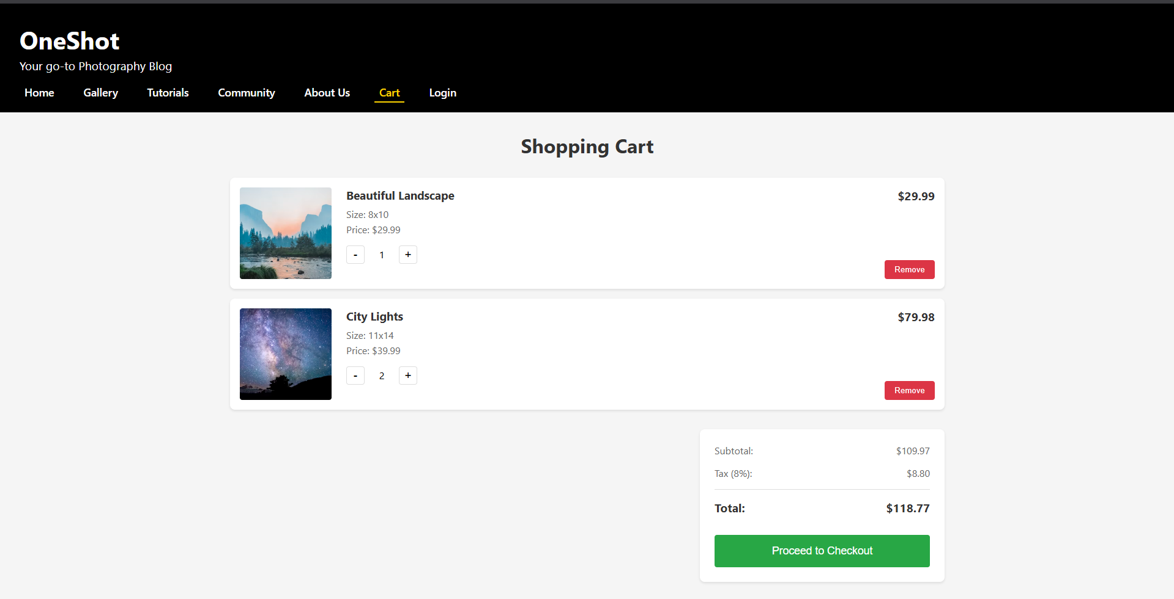

## **Code:**

G. Login page:

code:

import React, { useState } from 'react';

import { useAuth } from '../context/AuthContext';

import { useNavigate } from 'react-router-dom';

import Header from './Header';

import './Login.css';

const Login: React.FC = () => {

const [email, setEmail] = useState('');

const [password, setPassword] = useState('');

const [error, setError] = useState('');

const { login } = useAuth();

const navigate = useNavigate();

const handleSubmit = async (e: React.FormEvent) => {

e.preventDefault();

try {

await login(email, password);

navigate('/'); // Navigate to gallery page after successful login

} catch (err) {

setError('Invalid email or password');

}

};

return (

<>

<Header />

<div className="login-container">

<div className="login-content">

<div className="login-image">

<div className="image-overlay">

<h2>Welcome Back!</h2>

<p>Access your photography collection and continue your creative journey</p>

</div>

</div>

<div className="login-box">

<h2>Sign In to OneShot</h2>

<p className="login-subtitle">Your Photography Community</p>

<form onSubmit={handleSubmit}>

{error && <div className="error-message">{error}</div>}

<div className="form-group">

<label htmlFor="email">Email</label>

<input

type="email"

id="email"

value={email}

onChange={(e) => setEmail(e.target.value)}

placeholder="Enter your email"

required

/>

</div>

<div className="form-group">

<label htmlFor="password">Password</label>

<input

type="password"

id="password"

value={password}

onChange={(e) => setPassword(e.target.value)}

placeholder="Enter your password"

required

/>

</div>

<div className="form-options">

<label className="remember-me">

<input type="checkbox" />

<span>Remember me</span>

</label>

<a href="#" className="forgot-password">Forgot Password?</a>

</div>

<button type="submit" className="login-button">

Sign In

</button>

<div className="social-login">

<p>Or continue with</p>

<div className="social-buttons">

<button type="button" className="social-button google">

Google

</button>

<button type="button" className="social-button facebook">

Facebook

</button>

</div>

</div>

<p className="register-link">

Don't have an account?{' '}

<a href="/register" className="register-anchor">

Create an account

</a>

</p>

</form>

</div>

</div>

</div>

</>

);

};

export default Login;

## **Output:**

G. Login page output:

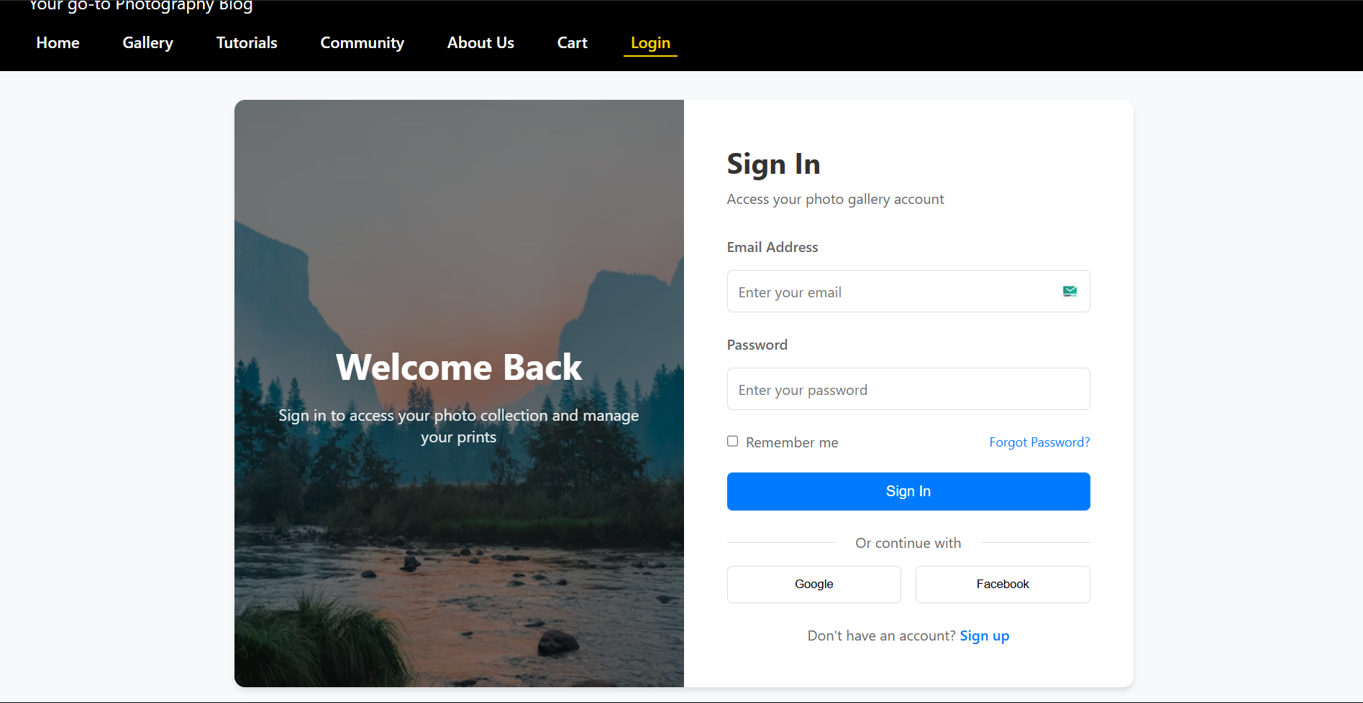

## **Code:**

H.Register page:

import React, { useState } from 'react';

import { useAuth } from '../context/AuthContext';

import { useNavigate } from 'react-router-dom';

import Header from './Header';

import './Login.css';

const Register: React.FC = () => {

const [username, setUsername] = useState('');

const [email, setEmail] = useState('');

const [password, setPassword] = useState('');

const [confirmPassword, setConfirmPassword] = useState('');

const [error, setError] = useState('');

const { login } = useAuth();

const navigate = useNavigate();

const handleSubmit = async (e: React.FormEvent) => {

e.preventDefault();

if (password !== confirmPassword) {

setError('Passwords do not match');

return;

}

try {

// In a real application, you would make an API call to register the user

// For now, we'll just simulate a successful registration and log them in

await login(email, password);

navigate('/'); // Navigate to gallery page after successful registration

} catch (err) {

setError('Registration failed. Please try again.');

}

};

return (

<>

<Header />

<div className="login-container">

<div className="login-box">

<h2>Create an Account</h2>

<form onSubmit={handleSubmit}>

{error && <div className="error-message">{error}</div>}

<div className="form-group">

<label htmlFor="username">Username</label>

<input

type="text"

id="username"

value={username}

onChange={(e) => setUsername(e.target.value)}

required

/>

</div>

<div className="form-group">

<label htmlFor="email">Email</label>

<input

type="email"

id="email"

value={email}

onChange={(e) => setEmail(e.target.value)}

required

/>

</div>

<div className="form-group">

<label htmlFor="password">Password</label>

<input

type="password"

id="password"

value={password}

onChange={(e) => setPassword(e.target.value)}

required

/>

</div>

<div className="form-group">

<label htmlFor="confirmPassword">Confirm Password</label>

<input

type="password"

id="confirmPassword"

value={confirmPassword}

onChange={(e) => setConfirmPassword(e.target.value)}

required

/>

</div>

<button type="submit" className="login-button">

Register

</button>

<p style={{ textAlign: 'center', marginTop: '1rem' }}>

Already have an account?{' '}

<a href="/login" style={{ color: '#007bff', textDecoration: 'none' }}>

Login here

</a>

</p>

</form>

</div>

</div>

</>

);

};

export default Register;

## **Output:**

H. Register page output:

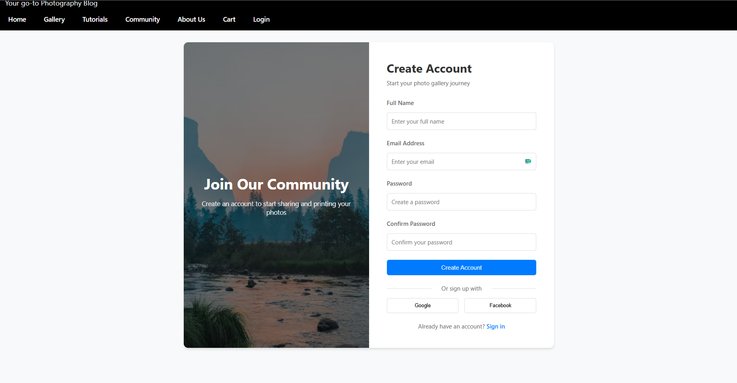

## **Conclusion:**

The development of the OneShot photography blog website provided a hands-on understanding of core web technologies such as HTML, CSS, and JavaScript. This assignment emphasized the importance of structuring web content using HTML, enhancing visual appeal through CSS, and implementing interactivity with JavaScript. The website design follows a clean, responsive, and user-friendly layout tailored for photography lovers. It includes essential pages such as Home, Gallery, Tutorials, Community, About Us, and user authentication forms (Login and Registration).

Through this assignment, we explored real-world web design principles, focused on visual aesthetics, and created a smooth navigation experience. The website serves as a strong foundation for creative professionals who wish to showcase their photography work online and build a digital presence. Overall, this assignment helped bridge the gap between theoretical web design concepts and practical application.